Civil Air Patrol Encampment

Basic Cadet
Operating Instruction

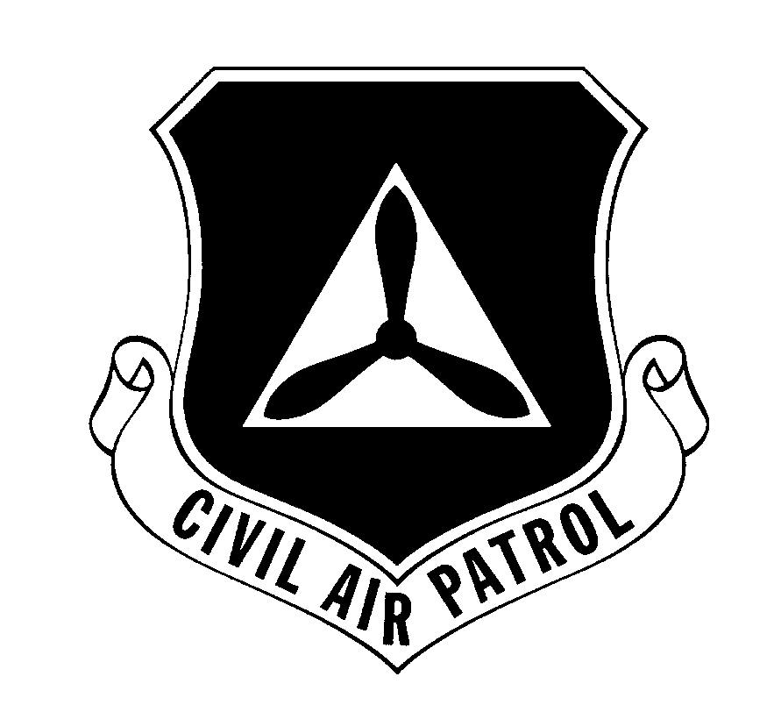

Cadet Programs, National Headquarters
United States Air Force Auxiliary
Civil Air Patrol

CAP NATIONAL HEADQUARTERS 4 MAR 98
United States Air Force Auxiliary

ENCAMPMENT OPERATING INSTRUCTION (OI)

Chapter | Subject | Page
1 | General | 2
2 | Safety | 4
3 | Attendance | 6
4 | Organization | 7
5 | Uniform & Appearance | 8
6 | Training | 10
7 | Awards | 11
8 | Barracks Procedures | 12
9 | Dining Hall | 14
10 | Customs and Courtesies | 16
11 | Restrictions | 17
12 | General Knowledge | 19
13 | Dining Etiquette | 22

Chapter 13 22
DINING ETIQUETTE

- This chapter is to help you with proper dining etiquette during formal dinners. This knowledge will be applicable for your whole life. In general, good manners and proper decorum is the rule. This list is not all-inclusive- these are rules to get you started.

- Keep your hand in your lap if unused. Keep your elbows off of the table. Place the napkin on your lap as soon as you sit. Sit erect, with your feet under your chair, and all four chair legs grounded. Do not talk when you have food in your mouth.

- Toasting is usually done with water or tea. Raise the glass and say “hear, hear” unless it is a silent toast. Keep your glass charged (not empty) when toasting.

- Each silverware piece is arranged for use outside in. If food A is served first, naturally, the outermost silverware pieces are for food A. Hold silverware like you would a pencil, not a shovel. When you’re finished with a silverware piece, lay it on top of the dish or plate- don’t prop it.

- If you must serve yourself food from a serving bowl, do not dig around for food- take your portion and pass it along.

- Use common sense- act as though one of your parents were there. Your Flt/CC can help you with any other questions you may have about protocol or manners.

21
_________________________________________________
Element Leader
_________________________________________________
Tactical Officer
_________________________________________________
Assistant Tactical Officer

Additional chain of command knowledge:

_________________________________________________
[ ]
_________________________________________________
[ ]
12.7 PROPER REPORTING PROCEDURE
(Not for memorization- you need only to understand it)

- Knock twice at the door and await instructions to enter.
- Position yourself two paces from the officer or their desk.
- Salute and report: “Sir/Ma'am/Sergeant, cadet (your grade- Basic, Airman, Airman First Class, etc., and your name) reporting as ordered” Ex: “Ma’am, Cadet Airman First Class Jones reporting as ordered”
- Drop your salute after it has been returned by the person you are reporting to. Sit at seats if asked to sit; relax only if told so.
- Converse professionally, using the proper courtesies.
- When your business is completed, ask “Will that be all (Sir, Ma’am, Sergeant)?”
- Stand up (if seated), take one step backwards, salute and say “Request permission to be dismissed.” When permission is given, wait to have your salute returned.
- Execute a facing movement toward the exit and depart.
Chapter 1 2
GENERAL

- You will be familiar with the contents of this OI immediately upon your arrival at encampment.

- Introduction. By nature, the CAP encampment is a rigorous training exercise. It is designed to challenge the cadet physically and mentally. It is the most important single challenge that you must meet before attaining the coveted General Billy Mitchell award (entitling you to cadet officer status.) Credit for successful completion of a CAP encampment must be earned; it is not automatically given for simply attending the encampment.

- Government Equipment. Some encampments have government owned equipment in the rooms or common areas. No one will use this equipment unless authorized by the Encampment Commander. Examples include: floor buffers, computers, dry erase boards, office supplies, filing cabinets, etc.

- Transportation. You are responsible for your own transportation. If you do not have a ride home, inform a staff member for help in arranging transportation.

- In- and Outprocessing. Proper encampment credit may not be granted if you do not properly in- and out-process. You receive your Certificate of Accomplishment at outprocessing. You will arrive and depart the host facility in uniform. Follow instructions given by staff.
3
- Contraband Items. You will have your personal belongings inspected by your TAC Officer for unauthorized items, to include: knives, flame producing devices, drugs (aspirin), tobacco, alcohol, pornography, food and personal radios/CDs. These will be stored in a safe place. All items will be returned at outprocessing, unless the item is illegal (tobacco, alcohol and pornography). Money over $10 will be collected and stored during the encampment, and can be accessed anytime from the TAC.

- Dismissal or Withdrawal. Each cadet in attendance is responsible for conducting themselves in a manner reflecting credit upon themselves and CAP. Misconduct may subject you to dismissal from the encampment without credit (see CAPM 50-16). Dismissal will be based on an impartial investigation by the Encampment Commander or their designated representative. You will be permitted to withdraw from encampment without prejudice for reasons of sickness or hardship. Encampment credit cannot be granted if you withdraw, unless you satisfactorily complete at least 80 % of the scheduled training.

- Motor Vehicles. Any cadet who brought a motor vehicle to the encampment must be aware that they cannot use the vehicle during the activity. It will be parked, locked and the keys turned into the Encampment Commander.

- Protocol. During the encampment, you will carry with you at all times your CAP ID card (or equivalent letter from home squadron commander) and this OI, except when showering.
20
_________________________________________________
Chief of Staff, USAF
_________________________________________________
Commander, Air Education & Training Command
_________________________________________________
Commander, Air University
_________________________________________________
Commander, USAF-CAP
_________________________________________________
National Commander, CAP
_________________________________________________
Encampment Commander
_________________________________________________
Commandant of Cadets
_________________________________________________
Cadet (Wing) Commander
_________________________________________________
Deputy Cadet Commander
_________________________________________________
Wing First Sergeant
_________________________________________________
Group Commander
_________________________________________________
Squadron Commander
_________________________________________________
Squadron First Sergeant
_________________________________________________
Flight Commander
_________________________________________________
Flight Sergeant
19
- CAP is composed of 8 regions and 52 wings. Each wing represents each state, plus the District of Colombia and Puerto Rico.

- CAP is comprised of three missions: Aerospace Education, Emergency Services, and the Cadet Program.

- There are four phases to the CAP Cadet Program:
- Phase I, Introduction
- Phase II, Learning
- Phase III, Leadership
- Phase IV, Executive

- CAP Motto: Semper Vigilans - Always Vigilant
(pronounced: “Sem-Purr Vih-gih-laanz”)

- DEFINITION OF LEADERSHIP

“The art of influencing and directing people in a way that will win their obedience, confidence, respect and loyal cooperation in achieving a common objective.”

- CHAIN OF COMMAND

_________________________________________________
Commander in Chief
_________________________________________________
Secretary of Defense
_________________________________________________
Secretary of the Air Force
_________________________________________________
Chairman, Joint Chiefs of Staff

Chapter 2 4
SAFETY

- It is the responsibility of every cadet and senior member at encampment to promote and observe all safety precautions.

- Safety violations may be reported through normal channels or you may go directly to your Tactical Officer.

- Barracks - the following is a general list of general safety rules for use while in the barracks. Local rules will be posted.
- Running is not permitted inside buildings.
- Electrical appliances will be unplugged when not used.
- All personnel will be aware of the evacuation procedures in their area at all times, i.e. evacuation routes, fire telephone number, extinguisher location and type, etc.
- All fires (or possible fires) will be reported to the fire department and then to your immediate superior.
- While sleeping, you will have your gym shoes (unlaced) placed next to your bunk. This allows you to quickly put on your shoes in case there is an evacuation.

2.4 Road Guards.
- Road Guards will wear a reflective vest while marching.
- In hours of darkness, element leaders and road guards will carry a flashlight and will have it turned on while traveling on any street.
- The flight staff will assign three road guards. Only one road guard is necessary for each direction of traffic.

5
- Each road guard will stand at parade rest and hold his/her right arm forward with fingers together and palm facing out. If dark, the flashlight will be held in the right hand, and will be tilted back and forth while standing in the roadway.
- Road guards will safely double-time to and from their positions.

2.5 Charge of Quarters (CQ)
- The purpose of CQ duty is to maintain fire watch and also interrogate any person entering the barracks at nighttime.
- Cadets assigned to CQ duty will report in the duty uniform of the day.
- Each CQ will carry a flashlight with a colored filter. During rounds, the CQ will check for signs of fire, cadets or staff in restricted areas (i.e. male in female area or vice versa), and the ID of anyone entering the barracks from outside.
- Each CQ will maintain the CQ log, reporting all shift changes and unusual occurrences. The completed log will be turned in to the Wing 1st Sergeant each day.
- CQ shifts are one hour. After 45 minutes into each shift, the previous CQ will awaken the next CQ. They will double check with 5 minutes to go to the shift change to ensure the cadet is awake. Males will not wake females; females will not wake males, under any circumstance
- Schedule of CQ duty will be posted in designated area. Each cadet will probably be assigned CQ duty at least once during encampment.
- Encampment-specific rules will be posted by the Wing or Squadron First Sergeant(s). The 12 general orders will be posted in a visible location for the CQ’s to reference.
- Chapter 12 18
GENERAL KNOWLEDGE

- General. The cadet must memorize the following items word for word. This added task (along with academics and leadership training) gives the cadet experience at thinking under pressure. It is hoped that the cadet will find that all of the material is of some use to him/her after encampment, and indeed all items included should be familiar to all cadets.

- THE CADET HONOR CODE

I will not lie, cheat, or steal, nor tolerate anyone among us who does so.

- THE CADET OATH

I pledge that I will serve faithfully in the Civil Air Patrol Cadet Program, and that I will attend meetings regularly, participate actively in unit activities, obey my officers, wear my uniform properly, and to advance my education and training rapidly to prepare myself to be of service to my community, state and nation.

- CIVIL AIR PATROL FACTS

- CAP was formed on 1 Dec 1941, with Major General John F. Curry as the first National Commander.

- During WWII, CAP coastal patrols spotted 173 German submarines. 57 depth charges and 83 bombs were dropped, sinking 2 submarines.
- Chapter 11 17
RESTRICTIONS

- Cadets will not gamble, smoke, use any drugs, including tobacco preparations, or consume alcohol at any time during the encampment.

- The use of any non-prescription medications must be cleared by the Medical Officer or designated representative before being taken at encampment.

- You will not leave the barracks area at anytime except when authorized. All cadets will march and square corners when in formation; two or more cadets constitutes a formation.

- Sunglasses will not be worn in formation unless they are authorized by the Medical Officer or designated representative.

- Personal stereos, alarm clock radios, televisions, Walkman or CD players will not be used anytime during the encampment.

- Barracks areas of members of the opposite sex are prohibited from _________ to __________ for all personnel. Your flight commander will give you the specific times. When entering barracks areas of the opposite sex during authorized times, doing official business only, shout “Male (or Female) in the barracks” so all can hear. Do not enter until cleared- someone may be changing. If there is no response after three honest tries, assume no one is in the area and enter.
Chapter 3 6
ATTENDANCE

- Absence from duty. Only the Encampment Commander, Commandant of Cadets, Medical Officer or your Tactical Officer may excuse you from duty or formations. If you are excused, you will receive written notice confirming your status. You will notify your Flight Commander and report to your Tactical Officer. At all formations, the Flight Commander will report all absences as directed. When you miss a part of a training session, you will attend as much of the remaining portion as possible.

- Encampment Credit. Credit for completing a CAP encampment is by no means automatic and is granted by CAP National Headquarters, upon receipt of a report from the Encampment Commander recommending that credit be granted. You must satisfactorily complete at least 80 % of the scheduled training and instruction, as determined by the Commandant, to receive encampment credit.

Chapter 4 7
ORGANIZATION

- Structure. The encampment is organized as a cadet wing (or group), with subordinate groups (if a wing), squadrons and flights. The flight is the basic training unit of the encampment.

- Cadet Staff. The cadet staff is selected by the Commandant of Cadets from advanced cadets who have applied for a staff position. All cadet staff members have attended at least one previous encampment.

- Tactical Officer. The Tactical Officer is a CAP Senior Member assigned to instruct, observe, and evaluate members of the flight. The TAC Officer is also the flight staff’s mentor. The health and well-being of the cadets within the flight is the responsibility of the Tactical Officer. You may look to him or her for guidance with any problem.

- Chain of Command. A cadet desiring to report to a higher level of command will do so through all intermediate echelons of command. If you desire to talk to your Tactical Officer or a chaplain, you may do so at any time, by making a request to a flight staff member. A request to speak to the Tactical Officer or chaplain will never be denied and will be granted immediately.

- In-flight Positions. You may serve in a responsible role in some capacity during the encampment. Element leader, flight standardization officer, intelligence officer, knowledge officer and guidon bearer are positions available for assignment. Your flight staff will brief you on the rules, restrictions, duration and details for each job, and make selections.
Chapter 10 16
CUSTOMS AND COURTESIES

- You will briskly and silently remove your headgear with your right hand immediately upon entry into a building or under a canopy or cover. Headgear is not worn indoors or on a flight line.

- You will salute all officers, senior or cadet, as defined in CAP regulations.

- All cadets may attend the church of their faith on the appropriate day.

- You will double time when proceeding to or from formation, except when returning from a meal formation or when carrying bulky articles.

- You will stand at attention when addressing or being addressed by a staff member unless the staff member directs otherwise.

- When asked a direct question, your answer will be clear, brief and concise. Do not repeat the question when asked.

- You will not be seated in classrooms or vehicles until directed to do so. When first seated, you will be in the position of “seats,” with hands on knees, elbows unbent, back straight and not resting on seat back, and eyes locked straight ahead, as if you were at attention until given “at ease.”

15
9.7 Cadets will sit erect with eyes on the food or straight ahead while eating. Cadets will be at ease in the dining hall while eating. If a cadet is addressed by an officer, he/she will come to the position of seated attention (“seats”).

9.8 Conversation is not permitted between basic cadets unless specifically authorized. Talking between tables is not permitted. Staff members are allowed to talk because meals are often the only opportunity they have for discussions.

9.9 When the table is finished eating, cadets will push the chairs in and depart dining hall, leaving trays as directed.

9.10 You will depart the dining hall without delay, in a military manner, and will proceed directly to your flight formation outside the dining hall.

9.11 KP Duty (if required by the needs of the encampment)
- Flights will be assigned KP duty per the encampment schedule. The entire flight will fully participate when assigned.
- The uniform for KP is BDU's without the blouse.
- The flight staff will report to the Kitchen Ops OIC per the training schedule, and will depart when dismissed. If the next scheduled event is a tour or classroom instruction, flights will NOT be late for these events.
- Cadets will come under the supervision of the Mess Operations OIC for KP.
- KP duty will consist of, but is not limited to, washing dishes, serving, restocking condiments & food, emptying garbage cans, cleaning the mess hall, policing the area.

Chapter 5 8
UNIFORM & APPEARANCE

5.1 Grooming Standards. All members of CAP must be well groomed and assure that their personal appearance at all times reflects proper credit upon themselves and CAP. Haircuts and hairstyles, along with other grooming standards, will be in accordance with CAPM 39-1, “Civil Air Patrol Uniform Manual.” You are encouraged to familiarize yourself with this manual.

5.2 General Appearance. You will be in proper uniform at all times. You are expected to maintain a high standard of appearance. Uniforms will be neat and clean at all times. All buttons with the exception of the neck button will be buttoned. No items will be carried in shirt pockets. Uniforms will be worn in accordance with CAPM 39-1, “Civil Air Patrol Uniform Manual.”

5.3 Uniforms. The uniform combinations to be worn during the encampment are outlined on the encampment equipment list. This form should have arrived with your acceptance packet.
- Short Sleeve Blues Uniform (Blues). Consult your CAPM 39-1 and cadet workbook for a complete description. Females will wear skirt or slacks based on availability and policy.
- Physical Training/Barracks Uniform:
BDU, white or Encampment T-shirt, crew neck, tucked in
Athletic shorts, BDU pants (tied at ankles), or sweatpants
Gym socks, white (with stripes OK)
Athletic shoes
Athletic supporter or Bra

9
- Battle Dress Uniform (BDU). The utility uniform. Consult your CAPM 39-1 and cadet workbook for a complete description.
CAP cutout placement
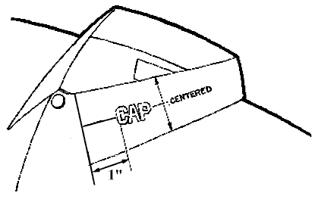
5.4 Personal Hygiene.
- You are expected to maintain a high standard of personal hygiene. You will take at least one (1) shower per day. Deodorant will be used. Underwear will be changed daily. Male cadets will be clean shaven (mustache excepted).
- Since time is of paramount importance when using the shower facilities, speed is required. Although cadets are not accustomed to this at first, your shower should be of short duration- two minutes or less. It is important that your showers are quick, but also done completely. There are many people waiting to use the showers, with limited time to use them. When using sinks, avoid splashing water everywhere. Be sure to check for all of your personal belongings before leaving an area- shampoo, soap, soap trays, clothes, etc. They will be collected at the end of the night if you forget them. Also, keeping the latrine and shower area(s) as neat as possible saves time cleaning it later.
Chapter 9 14
DINING HALL

9.1 All cadets will file into the dining hall in a single file column. When the line halts, you will assume the position of parade rest. Prior to moving forward, you will come to attention, march forward, and again assume parade rest when stopped (unless otherwise instructed; base policy may prohibit this).

9.2 After receiving trays of food, you will proceed to the most distant vacant chair on the designated area of the dining hall. You will not start a new table until the current open table is filled.

9.3 All items other than food (hats, road guard vests, notebooks, etc.) will be stacked neatly on the floor underneath the chair, or next to if it is not possible to put it underneath.

9.4 Only one hand will be used for eating. The other will be kept in your lap except when cutting meat, buttering bread, etc.

9.5 You will not be denied any portion of your meal. Take as much food as what you want, but eat all of what you take. Seconds may be obtained after finishing the first helping.

9.6 You are expected to eat and maintain a properly balanced daily diet. You will not consume carbonated beverages unless specifically authorized.

13
- All uniforms not being worn will be in inspection order.

- Shirts and shoes will be worn at all times in the barracks, including going to and from showers.

- Barracks telephones will not be used to initiate calls, except in an emergency such as fire.

- Cadets will maintain and police the grounds adjacent to their barracks.

- Spare hangers, luggage, and extra equipment will be neatly stored in an extra room (if available).

- When using a stairway, use every step and the railing(s). Running, skipping steps, or jumping is not permitted.

- Glass on windows will not be touched except for cleaning and opening/closing.

- Articles will not be thrown out of windows at any time.

- Personal Time. Personal time is a privilege offered in the evening. During this time encampment staff will not task you. You may do as you wish, as long as you conduct yourself with discipline and decorum, within the established encampment rules. Examples of appropriate activities: an extra shower, shining shoes, preparing personal items for inspection, or quiet conversation with flight members. Horseplay will not be tolerated during personal time (or any other time.)

Chapter 6 10
TRAINING

6.1 Course Content. The course content at encampment
will include at least the following:

USAF Mission & Structure | Attitude and Discipline
USAF-CAP Relationship | Opportunities in CAP
Physical Training | Emergency Services
Moral Leadership | CAP Organization & Mission
Drill and Ceremonies | Functions of an USAF Base
Customs and Courtesies | Leadership Laboratory
Wear of the CAP uniform | Encampment Electives

Each cadet will read and have a working knowledge of CAPM 50-1 “Introduction to CAP”, CAPP 151 “Customs & Courtesies”, “Leadership: 2000 and Beyond” Chapter 1, CAPM 39-1 “Uniform Manual” and AFMAN 36-2203 “Drill & Ceremonies”, prior to their arrival to encampment.

6.2 Examinations. There may be a pre-exam and final examination. These tests are used to measure the effectiveness of the academic training effort. These tests are also the basis for awards in the academic excellence category.

6.3 Evaluation. Basic Cadets will be evaluated constantly by the Flight staff and TAC officer from the moment you arrive until you have departed. Evaluation of your performance will be on leadership, academics, activities and physical training.

Chapter 7 11
AWARDS

7.1 Awards. Awards are not designed to be won. An award is formal recognition of outstanding performance or capability. There are two kinds of awards, individual and group with many categories. Below are listed possible awards that may be given out at encampment.

7.2 Individual Awards.

- Wing/Group/Squadron/Flight Honor Cadet
- Wing/Group/Squadron/Flight Academic Honor Cadet

7.3 Daily Group Awards.

- Honor Flight
- First Place for Drill
- First Place for Uniform
- First Place for Barracks
- First Place for Knowledge
- Honor Squadron

7.3 Encampment Group Awards.

- Honor Flight
- Honor Squadron
- Wing Volleyball Champions

Chapter 8 12
BARRACKS PROCEDURES

- Cadets will be familiar with all items on the flight bulletin board, if available (or equivalent).

- Cadets will stand at attention in hallways to allow staff members to pass. Cadets will not come to attention on stairways, (for safety reasons) but will allow staff members to pass.

- No unnecessary noise is permitted in the barracks at any time.

- Any items borrowed from another flight (i.e., buffers, mops, etc.) will be returned as soon as possible.

- Cadets will sleep between sheets, on a mattress, on a bunk. Bunks will be occupied only when so directed.

- Broken or defective equipment will be reported immediately to the flight sergeant or commander.

- Any personal items left in the latrine will be confiscated.

- All latrine facilities and all barracks facilities will be fully utilized. None will be reserved “For Inspection Only.”

- Barracks will be kept neat and clean and will be subject to inspection anytime during the duty day.

- Basic cadets will not get up in the morning until “First Call” sounds. Wrist watch alarm use is not permitted.

