<BLANK> WING CADET PROGRAMS

Encampment
Workbook

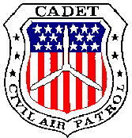

<Encampment Location and name>

Overview

This workbook has been designed as part of your academic curriculum here at encampment. This book will not be collected by squadron staff or corrected and returned to you. Instead it is a tool for you to use to gain knowledge about many of the important topics and skills we will cover this week.

Hopefully you will find all of the information in this workbook to be useful. In many sections portions of the CAP regulations or manuals have been reproduced. Do not mistake these for the regulations themselves. If you have a question – look it up! Do not rely on this document as your sole source of information or as an authoritative word on matters pertaining to the administration of CAP.

Your Flight Staff will help you complete the book throughout the week. Strive to make every answer correct. To do this you must read the information within. Do not take the easy route and simply wait for your Flight Staff to give you the answers. While possible, it is not the route of a cadet with integrity, discipline, or honesty. Strive for these things as that is part of being and succeeding at encampment.

Lastly, much of this information will appear on the final examination. That examination is the basis for the Academic Excellence awards. Discipline yourself and demand excellence and you will succeed.

Section One – The History of CAP

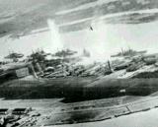
Pearl Harbor propelled the United States into World War II, but many Americans saw the AXIS threat long before Dec. 7, 1941. Among them were nearly 150,000 men and women involved in aviation.

As early as 1938, they began to argue for the creation of an organization to harness their aviation resources to aid the nation in the event America entered the conflict. Their efforts, led by writer-aviator Gill Robb Wilson and supported by Gen. Henry "Hap" Arnold, resulted in the creation of the Civil Air Patrol on Dec. 1, 1941 - one week before Pearl Harbor.

First organized under the Office of Civilian Defense, headed by former New York Mayor Fiorello LaGuardia, Civil Air Patrol members became the "Minutemen" of World War II, volunteering their time, resources, and talents to defend the nation's borders and fill the gaps as men and resources were being mobilized to fight abroad.

The War Department, especially the Army Air Forces, recognized the important roles performed by CAP. In April 1943, CAP was reassigned from the Office of Civilian Defense to the War Department and placed under the jurisdiction of the Army Air Forces.

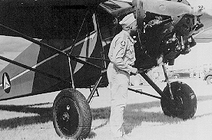
These Flying Minutemen, all volunteers, performed valiantly during the war. They performed many missions including coastal patrol to search for enemy submarines, search and rescue missions throughout the United States, cargo and courier flights to transfer critical materials and personnel, and even towing targets so Army Air Corps personnel could practice air-to-air gunnery techniques - a very risky mission with new gunners.

In all, these volunteers amassed a stunning record - flying more than half-a-million hours, sinking two enemy submarines, and saving hundreds of crash victims. A thankful nation recognized the vital role CAP played during the war and understood the organization could continue to provide invaluable help to both local and national agencies.

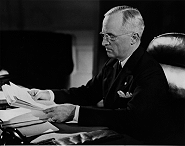
On July 1, 1946, President Harry Truman signed Public Law 476 that incorporated CAP as a benevolent, nonprofit organization. And on May 26, 1948, Congress passed Public Law 557 that permanently established CAP as the Auxiliary of the new U.S. Air Force. This law also gave the Secretary of the Air Force the authority to provide financial and material assistance to the organization.
Section One Review Questions

- Civil Air Patrol was formed one week before ____________________________ which was a major factor in the United States entering into World War II.
2. The Civil Air Patrol has served under a number of different agencies. Circle the agencies that CAP has been a part of:

- The US Navy
- The Department of Transportation
- The Office of Civil Defense
- The US Army
- The US Air Force
- The Army Air Forces

- Since CAP was founded in 1941, what anniversary did it celebrate in 1991? _________
4.  True  False: Public Law 476 made CAP the official auxiliary of the United States Air Force?
- Place an “x” next to the missions you could have performed had you been one of CAP’s “flying minutemen” during World War II.
- Target Towing
- Search and Rescue
- Submarine patrols and bombing
- Courier services
- Material transport
- Air Combat Patrols
- President Harry S. Truman is famous for making the decision to drop nuclear bombs on the Japanese cities of Hiroshima and Nagasaki. To CAP members he is also famous because:
________________________________________________________________________________________________________________________________________________
7. There were two people who were very involved in starting Civil Air Patrol. One served as CAP's first National Commander and was named _________________________. The other was a writer who has now had the Level V Senior Training Award named after him. He was ______________________________.

Section Two – The Organization of CAP

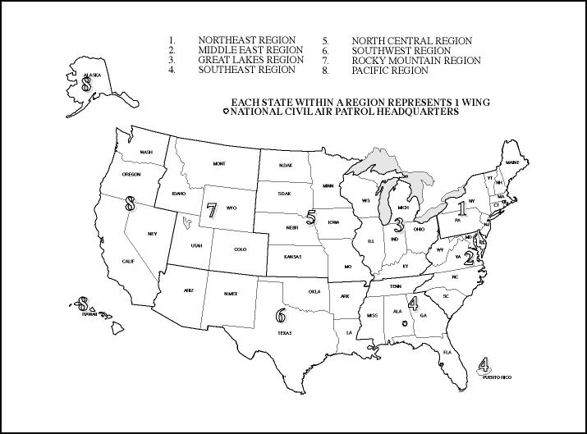
The Civil Air Patrol is a civilian organization but, as the civilian Auxiliary of the U.S. Air Force, it comes as no surprise that it is organized along military lines. CAP is organized into eight geographic regions. These regions are subdivided by the states falling within their boundaries and each state has a CAP wing. Additionally, the District of Columbia and Commonwealth of Puerto Rico have CAP wings.

These 52 wings are then subdivided into groups, squadrons, and flights depending on their size. There are more than 1,700 CAP units, half of which are composite squadrons or squadrons that have both senior and cadet members.

The highest governing body of CAP is the National Board, chaired by a member of the CAP Corporation whose title is National Commander. This position is held by a CAP Brigadier General elected by the members. Other members of the Board include the eight region and 52 wing commanders. This governing body also includes an elected National Vice Commander, Chief of Staff, Legal Officer, Finance Officer, and Controller - all civilian volunteers who have no active duty Air Force obligations or privileges.
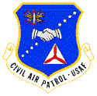
There is one key position on the National Board that ties the CAP Corporation to the U.S. Air Force - the Senior Air Force Advisor. The advisor's position is held by an active-duty Air Force Colonel who, in addition to serving as the Senior Air Force Adviser, is responsible for all active duty and DoD civilian employees who provide liaison oversight and advice to the CAP organization. In this capacity, the Senior Air Force advisor is also the CAP-USAF Commander.

Sound confusing? It's really not. When Congress enacted Public Law 557 in 1948, they determined that active-duty Air Force personnel should be assigned to provide advice and assistance to the organization. Hence, Headquarters CAP-USAF was established.

In addition to the Air Force staff at CAP's National Headquarters, CAP Liaison regions have a small staff headed by a commander and a staff of six other officers, NCOs and DoD civilians who perform aerospace education and training, logistics, and administration and operations functions.

The members of the CAP-USAF unit fall under the command of Air University. Air University is the Air Force organization responsible for operating many of the schools such as Air War College and Squadron Officers School. Air University in turn reports to the commander of the Air Education and Training Command (AETC).

Each of the 52 wings also has a liaison noncommissioned officer and some also have a liaison officer - both who are retired U.S. Air Force members.

Within each Wing are the individual units that are the lifeblood of CAP. There are three types of CAP units: Cadet, Composite, and Senior squadrons. Each type of squadron serves a special purpose in furthering the CAP mission.
"As the active force draws down, the Air Force will engage in increased burden-sharing with its Guard, Reserve and Auxiliary (CAP) components. It is critical that U.S. Air Force installation and unit commanders provide priority support to CAP--which in turn enhances CAP mission readiness and a payback in increased mission support to the Air Force by its civilian Auxiliary."

Mr. Bryan Sharratt
Deputy Assistant Secretary of the Air Force

Cadet squadrons are comprised mainly of cadets and of seniors who are motivated by working with cadets. The squadron typically focuses on cadet training and cadet advancement. The senior members tend to advance their training on their own and by their own design.

Senior squadrons are the opposite of cadet squadrons in that they are comprised entirely of seniors. Cadets may not belong to a senior squadron. Senior squadrons tend to focus on furthering the expertise of their members and on advancement through the Senior Training Program.

A Composite squadron combines the two previous types of squadrons into one. In this type of unit, cadets and senior operate their training programs side by side. They also assist each other in accomplishing the missions of CAP. In a Composite unit the Deputy Commander for Cadets (CDC) tends to oversee the cadet training program, while the Deputy Commander for Seniors (CDS) oversees the senior program.
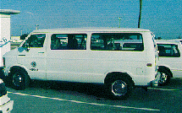
Beneath the squadron level is the CAP Flight. A unit that is in “flight status” can only remain that way for a short period of time before the unit must either meet “squadron status” or be deactivated. Frequently new CAP units start out as a flight beneath an established CAP unit. Occasionally squadrons lose so many members, and don’t recruit new ones, that they fall below the minimum number of members and are forced to become a flight. When this happens, the unit must recruit enough new members to regain their squadron status or the unit may be deactivated in accordance with CAP regulations.
Section Two Review Questions

- There are three types of units in CAP:
- S___________________
- C___________________
- C___________________
- C/MSgt Smith is in charge of setting up Color Guard Competition. He wants to use a building at the <insert location> Base. Who should he talk to?
- The Wing Adjutant General
- The Wing Commander
- The Wing Liaison Officer
- Nobody, just show up and ask to use it on the day of the event.
- The National Boards is made up of the ________ Wing Commanders, the ______ Region Commanders, and an elected National Commander, National Vice Commander, Chief of Staff, Legal Officer, Finance Officer, and Controller.
- The Commander of CAP-USAF is also the ______________________________.
- The Headquarters of CAP is located at Maxwell AFB, Alabama. This base is also home to Air University, which falls under the direction of what Major Command (MAJCOM)?
______________________________________
- Why is it important to keep recruiting new members and to retain current ones if you want your unit to stay a squadron? ___________________________________________________________________________________________________________________________________________
- There are 52 CAP Wings. Each state has a wing and where do the other two come from? _________________________________________________________________
8. Identify all the Wings in ____________ Region:
Section Three – The CAP Cadet Program
The CAP Cadet Program accepts young men and women who meet certain eligibility requirements. As a cadet, you participate in a program based on a military model that has been derived from CAP’s status as the Air Force’s official auxiliary. Through dedication and achievement you can promote and gain more responsibility and duties as you progress through the Cadet Program.

Membership
To join, a young person must be:
- 12 years old OR 11 years old AND enrolled in sixth grade
- Be under 18 years old (you may remain a cadet until 21 though)
- A U.S. citizen or an alien admitted for permanent residence
- of good moral character
- have a satisfactory academic record
- be approved by the unit Membership Committee

New members apply on a CAPF 15 which must be signed by the applicant, his/her parents, and the Unit Commander (or designee).

Program Management
Effective 01 June 99, a new directive was issued by National Headquarters that changes how the Cadet Program is managed. The new regulation is CAPR 52-16. This regulation instructs CAP commanders on how to carry out the cadet program. As a cadet you should become familiar with this regulation and its requirements. The revised program has 16 achievements divided up into four phases. Achievements 1-8 are named after historic aviators, while achievements 9-16 are named after different staff positions. Between the upper phases there are also “milestone” awards that recognize the effort and dedication it takes to get to those levels.

To earn a promotion each cadet must do the following for each promotion except the first:
- Pass an Aerospace Education test (currently at 60%)
- Pass a Leadership test (currently at 70%)
- Attend at least 50% of the Moral Leadership sessions during the promotion period
- Pass the Cadet Physical Fitness Test (CPFT)
- Participate actively in the unit
- Wait at least 60 days between promotions

Phase One – The Learning Phase
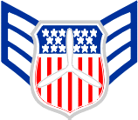
The first phase of the Cadet Program focuses heavily on learning about being a CAP cadet. New cadets learn about followership, drill, uniform wear, and the beginnings of aviation. There are four grades associated with this phase:
- New member = Cadet Airman Basic (C/AB)
- Complete Achievement One = Cadet Airman (C/Amn)
- Complete Achievement Two = Cadet Airman First Class (C/A1C)
- Complete Achievement Three = Cadet Senior Airman (C/SrA)
At the completion of Achievement Three, the cadet receives a certificate signifying their completion of Phase One and their passage into the CAP Cadet NCO Corps.

Phase Two – The Leadership Phase
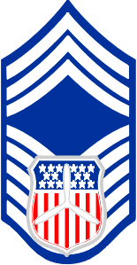
During this phase, cadets begin to exercise their leadership abilities by becoming Non-Commissioned Officers (NCO’s). As a NCO, the cadet must become a “participant-leader” and work with both his/her commanders and followers to accomplish the mission. It is the NCO that executes the plans and vision of the higher echelon officers. There are five grades associated with this phase:
- Complete Achievement Four = Cadet Staff Sergeant (C/SSgt)
- Complete Achievement Five = Cadet Technical Sergeant (C/TSgt)
- Complete Achievement Six = Cadet Master Sergeant (C/MSgt)
- Complete Achievement Seven = Cadet Senior Master Sergeant (C/SMSgt)
- Complete Achievement Eight = Cadet Chief Master Sergeant (C/CMSgt)
To leave this phase a cadet must pass a 100 question Aerospace/Leadership examination. Passing this difficult test will earn you the prestigious General Billy Mitchell Award and subsequent promotion to Cadet Second Lieutenant.

Phase Three – The Command Phase
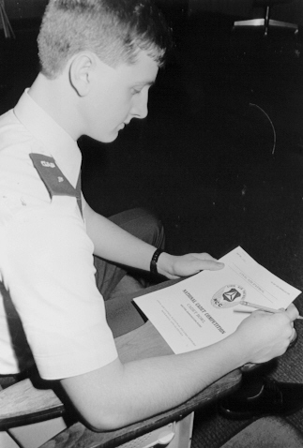
Having left the ranks of the Cadet NCO Corps you have now entered the realm of the CAP Cadet Officer Corps. Expectations are beginning to grow even higher as your professionalism and demeanor are constantly under review. Only a select percentage of dedicated cadets reach this level. As a Phase Three cadet you will begin to conduct long range planning for your unit and you will be responsible for more and more personnel. There are two grades in this phase:
- Complete the Mitchell Award = Cadet Second Lieutenant (C/2d Lt)
- Complete Achievement 10 = Cadet First Lieutenant (C/1t Lt)
Another milestone award, the Amelia Earhart Award, marks the end of this phase. To earn this award you must pass another 100 question Aerospace/Leadership test. Passage of the test allows you to be promoted to Cadet Captain.

Phase Four – The Executive Phase
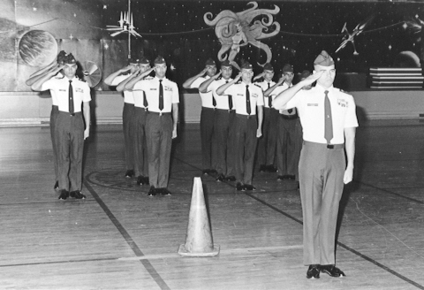
As you enter Phase Four you have made a subtle, yet distinct progression. During the previous phase you were a “junior officer” and as you enter Phase Four you begin to lose that label. As a Phase Four cadet you are expected to plan and have vision of where your unit is going. You no longer execute the specific details, that is what staff members do, instead you make long range plans and direct your unit towards strategic goals. There are two grades in this phase:
- Complete the Earhart Award = Cadet Captain (C/Capt)
- Complete Achievement 14 = Cadet Major (C/Maj)
At the end of this phase you have officially completed the CAP Cadet Program upon earning the Ira C Eaker Award. To earn this award, you must have completed all 16 achievements and have attended National Cadet Officer School, a Region Cadet Leadership School, or completed ECI Course 13.
- Complete the Eaker Award = Cadet Lieutenant Colonel (C/Lt Col)

The Final Destination – The Spaatz Award
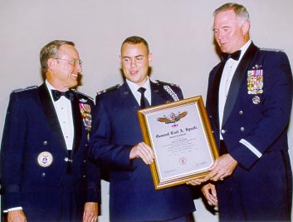
For a select few cadets, there will be one more major award in their CAP cadet careers. This award has been named for General Carl A Spaatz, the first Chief of Staff of the USAF. The Spaatz award comprises four tests:
- A 60 question Aerospace test
- A 60 question Leadership test
- A CPFT
C/Col James McCloud receives Spaatz #1376 from USAF Chief of Staff, General Michael Ryan and CAP National Commander, BGen James Bobick
- An essay written on an ethics topic
- You may only attempt to pass all four three times.
Because of the “three test limit,” many cadets attempt the Spaatz but few achieve it. According to The Spaatz Association’s website (www.spaatz.org) there have been only 1,400 Spaatz awards earned in the past 25 years.

Other Cadet Opportunities
The CAP Cadet Program offers you a wealth of opportunities and experiences that shouldn’t be missed. These opportunities include special activities, flight training, and scholarships.

Special Activities – Each year different echelons offer a wide range of special activities.
- Wing - Encampment, NCOS, Volleyball Competition, Color Guard Competition, Ski Trip, and Solo Encampment are some of the activities offered at the Wing level.
- Region – Region Cadet Leadership School, Cadet Conference, Region Conference
- National – These activities tend to be during the summer and are typically structured to familiarize cadets with the USAF.

- Air Force Space Command Familiarization Course
- Air Force Pararescue Jumping Orientation Course
- Air Education and Training Command Familiarization Course
- National Cadet Officer School
- National Non-Commissioned Officer School
- National Ground Search and Rescue School
- National Blue Beret
- Hawk Mountain Ranger School
- National Flight Academies
- National Glider Academies
- Embry-Riddle Aeronautical University Orientation Course
- Jacksonville University/Comair Academy Airline Training Track
- National Cadet Competition
- International Air Cadet Exchange

Flight Training – Training towards a Private Pilot’s license is available to all CAP cadets that meet FAA qualifications. Cadets typically must pay for their flight time, but that cost is at a huge discount over commercial instruction schools. Solo Encampment is a good way to get started on your flying qualifications.

Scholarships - Money for college and flight training is available through CAP scholarships. Specific qualifications and the different opportunities are outlined in CAPR 52-16.

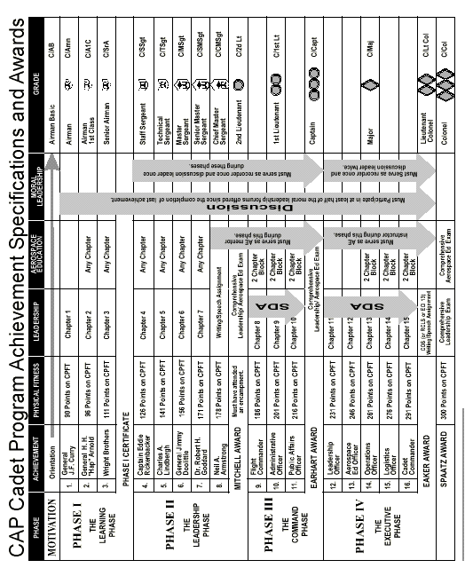
Section Three Review Questions

- The Cadet Program has ___ phases and ____ achievements. To move from one achievement to the next you must wait _____ days.
- Name the four major milestone awards:_______________________________________
- Cadets who are between the grades of C/SSgt and C/CMSgt are considered NCO's. What does NCO stand for and what do they do?________________________________
______________________________________________________________________
______________________________________________________________________
- You must either attend National Cadet Officer School, a Region Cadet Leadership School, or complete ECI Course 13 to earn what award and associated grade? ______________
- When you turn 21 years old what must you do?_________________________________
- ( )True or ( )False: You must be an officer to attend National Special Activities.
- Pick the Special Activity that sends you to a foreign country with other CAP cadets and CAP chaperones.
- National Blue Beret
- Pararescue Jumping Orientation Course
- International Air Cadet Exchange
- National Cadet Competition
- Circle the regulation that directs the CAP Cadet Program.
CAPM 39-1 CAPR 50-15 CAPP 151 CAPR 52-16 CAPM 50-16
- Write in the four major milestone awards and their corresponding grades:
Gen B____________________________________ C/___________
A________________________________________ C/___________
Gen I_____________________________________ C/___________
Gen C____________________________________ C/___________
10. Write down why you joined the CAP Cadet Program. Keep this book and in a few years revisit this section and see if your motivations are the same, similar, or totally different. You may be surprised!

Section Four - Uniforms
Civil Air Patrol cadets are expected and required to wear the prescribed uniform whenever engaged in CAP activities. However, there are many other youth groups out there who wear uniforms too. Boy Scouts, marching bands, cheerleaders, and sports teams all wear distinctive uniform to set them apart from other groups and to create a unity of appearance. So what is so special about the uniform that CAP cadets wear? The "specialness" comes from being able to wear an authorized version of the uniform that is worn by the United States Air Force!

Being able to wear the Air Force uniform is a privilege extended to us, but it is not a right. For that reason you must always wear the uniform with pride, discipline, and in compliance with all rules and regulations. CAPM 39-1, the CAP Uniform Manual, and its Wing supplements set the standard for uniform wear in CAP. In the following section we will touch on some basic uniform wear issues. You must realize that properly wearing your uniform is one of the most basic and required responsibilities you have as a cadet. Until you can demonstrate mastery of this task, your commanders will be very hesitant to give you any additional duties, responsibilities, or grade!

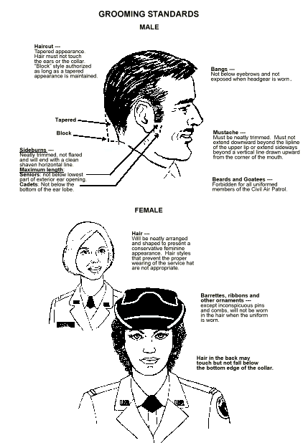
Grooming Standards
CAPM 39-1 outlines very specific standards that detail how your hair must look and how long it may be. Males must be clean-shaven except for a mustache and females must wear cosmetics that present a conservative appearance.

The Basic Service Uniform
The service uniform is worn when directed by your Commander. Typically there are worn during formal functions, non-strenuous activities, and other times when a dressy appearance is important. The basic minimum service uniform is:
- Short-sleeve, light blue shirt (males) or blouse (females)
- Dark blue trousers (female/male) or skirt (female)
- Blue belt/silver buckle (n/a for skirts or pants without belt loops)
- Blue flight cap (gender appropriate)
- Black shoes and socks (females with pants or males) or nylons (nude, black, or suntan shade)
- Insignia, CAP nameplate, shoulder patch, collar/lapel insignia, embroidered epaulet sleeve and flight cap emblem

The Basic Utility Uniform
The utility uniform, or battle dress uniform (BDU's), is worn when you are doing work, strenuous activities, or other times as directed by your Commander. The basic BDU uniform:
- BDU blouse (with sleeves cuffed or uncuffed as specified by your Commander)
- BDU pants (bloused over the top of the boot)
- Black boots
- BDU cover
- Blue belt/black buckle
- Brown or black T-shirt
- Insignia, CAP tape, nametape, shoulder patch

Wearing of the uniform
When you wear your uniform you must wear it with pride and properly at all times. You may wear your CAP uniform when conducting CAP duties, attending meetings, flying in orientation flights, or as directed by your unit commander. You may wear your uniform for up to one hour after a meeting or activity ends.

You must not wear your uniform if you are doing any of the following:
- Attend meetings of a group that the U.S. Attorney General has designated as totalitarian, Fascists, Communists, or subversive.
- Participate in any organization that supports denying other people their Constitutional rights by force or violence
- Participate in any group that seeks to alter the Constitution of the United States through unconstitutional means.
- Participating in any rallies, marches, speeches, or other activities not approved by the Air Force. Your presence in the Air Force uniform may lead other to believe that the Air Force supports the cause you are participating in.
- When in private employment or commercial interest where someone may construe your presence as the Air Force supporting your employer or business.
- When engaged in private employment
- Conduct any actions that may discredit upon the Air Force

Insignia, accouterments, and placement
The CAP Uniform manual specifically tells you where the different items go on your uniform. None of the placements are unusually difficult or troublesome, they simply take a little time and care when putting the items on to get them correct. If you are wearing insignia incorrectly you are out of uniform. By the time you are ready to become a NCO, your officers should no longer have to correct these types of items.

The following placements are for the short-sleeve service uniform:
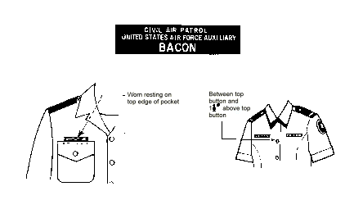
Collar Insignia - Worn one inch from the front edge of the collar and centered. CAP Cutouts must be shiny. Grade insignia is worn on the right and the CAP cutout is worn on the left.

Nameplates – One the male uniform, the blue CAP nameplate is placed so it rests on top of, but not over, the right breast pocket. For females, the nameplate Blouse: (pointed-collar) centered on right side even with or up to 1 1/2 inches higher or lower than the first exposed button; (rounded collar) center on right side 1 1/2 to 2 1/2 inches below bottom of the tab, parallel with ground.

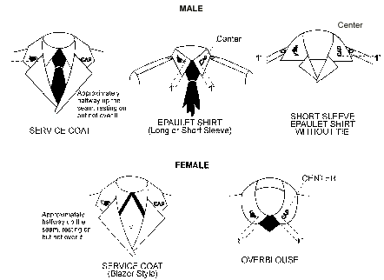
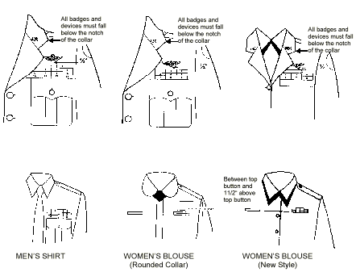
Ribbons – For males, the ribbons are placed on the left side and resting along the top of the left breast pocket. For females with the pointed collar blouse, ribbons are centered on left side even with or up to 1 1/2 inches higher or lower than the first exposed button. With the rounded collar blouse, the ribbons are centered on left side 1 1/2 to 2 1/2 inches below bottom of the tab, parallel with ground.

Belt, Buckle & Gig Line – For all males, and for females with belt loops, the belt is mandatory. Silver tip end of the belt extends beyond the buckle facing the wearer’s left; no blue fabric shows. Woven cotton web or elastic, solid or woven, belt with matching silver-color metal tip and buckle (oxidized silver or chrome-like finish).

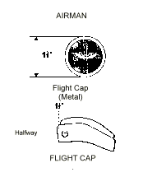
Gig Line refers to the line that is formed by the button fly portion of your shirt, your buckle, and the fly portion of your pants. This “line” should be straight down your shirt, across the buckle, and down the pants fly. The line must cross the buckle where the slight indentation is on the left side of the buckle.

Headgear – Your flight cap must fit on your head correctly. Males may not have any hair showing out of the front, while females may. The airman hat device is placed 1.5” in from the front and centered.
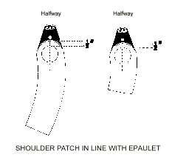
Shoulder Patch – Your Wing patch is worn on the left shoulder. It is to be centered off of the epaulet (not the back seam!) and ½” below the shoulder seam. Your commander must decide whether your unit places creases in your shoulder patch or not.

Pants/Trousers/Slacks/Skirts – Your pants must fit correctly and be the proper length. When you wear your pants there must only be one “break” in the leg before your pants meet the top portion of your shoe. For skirts, the skirt must fall between the top of the kneecap and the bottom of the kneecap.

Shoes – Your shoes must be all black and must be plain. They should be polished to a high shine. Some units allow their cadets to purchase pre-polished shoes, called patent leather, while others restrict that to only officers. You must wear black socks.

Other items – There are many little things that you must pay attention to when in uniform. The sign of a disciplined cadet is one who pays attention to even the most minor of details. Here are some common errors that you will want to avoid:
- Earrings: Only females may wear earrings and only one in each ear. It must be a small hoop or post and must be gold or silver in color.
- Rings: Jewelry is permitted but must be conservative and no more than three at any time.
- Hair devices: Females who put their hair up may do so. However the berets, bands, etc. that are used must match the color of your hair. Large ribbons, clips, scuunci’s, etc. are forbidden.
- Hair color: Your hair color must complement your skin tone in a conservative fashion. No blue, green, pink, purple, etc hair color.

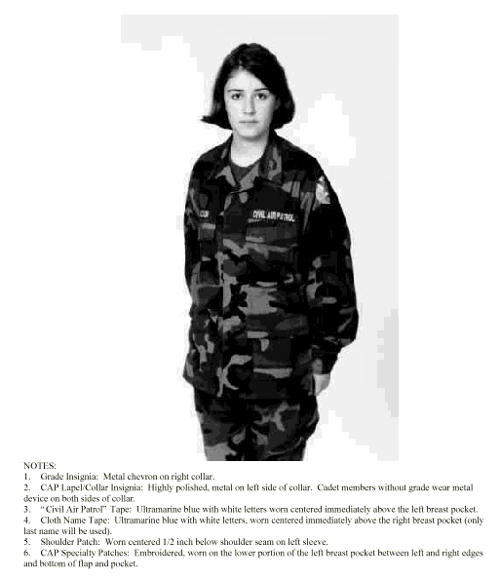
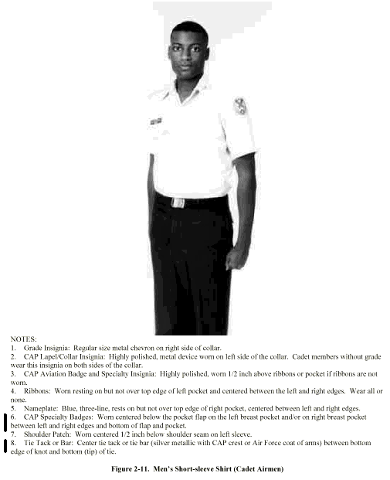
Your uniform is a reflection of you. Be proud of it and treat it well. Iron it and wash it frequently. Your BDU uniform is important too. Iron pockets and collars so they appear crisp. Check CAPM 39-1 for the proper placement of patches before putting them on to prevent doubling the work. Above all you must understand that your uniform tells the world what kind of cadet you are and how much discipline you have. You only get one chance to make that first impression.

Section Four Review Questions
- What CAP manual prescribes the rules of wearing CAP uniforms? ______________
- For each of the following measurements, put the corresponding uniform item next to it:
- ½” from shoulder seam and centered: Wing Patch (example)
- 1” up, parallel with front edge of collar, and centered:______________________
- 1 ½” inches in and centered:__________________
- Falls between the top and bottom of kneecap:_____________________
- No more than 3” bulk for females:________________________
- Rests upon the top of the left breast pocket:______________________
- If Cadet Sarah Smith has blond hair and puts it up when in uniform, which of the following rubber band colors should she use?
Blue Green Purple Yellow White Blond Brown
- Cadet Willis likes to wear his uniform a lot. Over the past two weeks you’ve seen him all over town in it. The following is a list of places you’ve seen him while in his uniform. Place an “x” next to the places that he shouldn’t have been wearing it:
- You stopped at McDonald’s and saw him working the fry machine in BDU’s
- You went with your grandfather to the local VFW post and saw him there making a presentation about CAP in his blues
- You stopped at Denny’s about 30 minutes after the meeting and saw him there with his parents in his blues.
- You went to a rally for your Squadron Commander, Maj John Puhlie, who is also running for city mayor, and saw Willis handing out CAP brochures and “elect Puhlie he’s no stoolie” buttons in his BDU’s.
- What color socks do you wear in blues if you are a male cadet or a female cadet with slacks?_________________
- Why is it important to wear a proper uniform?____________________________________
________________________________________________________________________
________________________________________________________________________
- The Air Force lets CAP members wear their uniform. This makes wearing the uniform a ________________________ and not a _______________.
- Cadets wear b_______ nameplates while seniors wear g_________ nameplates.
Section Five – Customs, Courtesies, and Drill
Besides wearing your uniform, mastering drill and mastering customs and courtesies are other important responsibilities of the Phase I and II cadet. The CAP Cadet Program works from the military heritage given to us by our Air Force partners. From this heritage we develop and share military customs and courtesies. The Cadet Program uses military drill as one of its primary instructional tools to teach leadership. In drill you begin from the basic and move to the advanced. You also move from the simplest of followers, as an element leader, and can move to the most complex of commanders, directing the actions of an entire Wing during a Pass-In-Review.

Drill Terms
To know what to do, you must first have a common frame of reference to work from. Many of these terms should be familiar to you, but some will be new. These terms have been taken directly from AFMAN 36-2203, which CAP uses as its Drill & Ceremonies Manual. Not all the terms have been taken, but the ones you must be familiar with have. Study them carefully and commit them to memory.

Alignment. Dress or cover.
Cadence. The uniform step and rhythm in marching; that is, the number of steps marched per minute.
Center. The middle point of a formation. On an odd-numbered front, the center is the center person or element. On an even-numbered front, the center is the right center person or element
Cover. Individuals aligning themselves directly behind the person to their immediate front while maintaining proper distance.
Depth. The total space from front to rear of any formation. An individual’s depth is considered to be 12 inches.
Distance. The space from front to rear between units. The distance between individuals in formation is 40 inches as measured from their chests to the backs of individuals directly in front of them. Flight commanders, guides, and others whose positions in formation are 40 inches from a rank are themselves considered a rank.
Double Time. The rate of marching at 180 steps (30 inches in length) per minute.
Dress. Alignment of elements side by side or in line maintaining proper interval.
Element. The basic formation; that is, the smallest drill unit comprised of at least 3, but usually 8 to 12 individuals, one of whom is designated the element leader.
File. A single column of persons placed one behind the other.
Flight. At least two, but not more than four, elements.
Formation. An arrangement of units.
Front. The space occupied by a unit, measured from flank to flank. The front of an individual is considered to be 22 inches.
Guide. The airman designated to regulate the direction and rate of march.
In Column. The arrangement of units side by side with guide and element leaders to the head.
In Line. The arrangement of units one behind the other with the guide and element leader to the extreme right flank.
Interval. The space between individuals placed side by side. A normal interval is an arm's length. A close interval is 4 inches.
Inverted Column. The arrangement of units side by side with guide and element leaders to the rear.
Inverted Line. The arrangement of units one behind the other with the guide and element leaders to the extreme left flank.
Mark Time. Marching in place at a rate of 100 to 120 steps per minute.
Pace. A step of 24 inches. This is the length of a full step in quick time.
Quick Time. The rate of marching at 100 to 120 steps (12 or 24 inches in length) per minute.
Rank. A single line of persons placed side by side.
Slow Time. The rate of marching at 60 steps per minute (used in funeral ceremonies).
Step. The distance measured from heel to heel between the feet of an individual marching.
Unit. Any portion of a given formation.

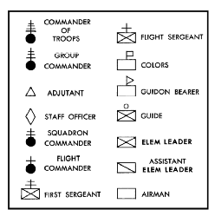

In teaching drill, symbols are often used to indicate the position of certain persons and units. The following are drill symbols you should know:

Customs & Courtesies
In both the civilian world and the military world we have customs and courtesies. Customs are those things we do because the group we belong to obligates us to. Courtesies are those things we do because we are disciplined, civil persons who believe in being courteous and polite. The following are some of the more common military customs and courtesies we follow in CAP.

Saluting – Saluting comes to us from the Middle Ages when knights would raise their visors with their right hand as a sign of friendship or peace. From that display has evolved today’s salute which is a sign of respect amongst military personnel. As a cadet airman or NCO you are required to salute:

- All CAP Cadet and Senior officers
- All officers of the United States military
- All officers of nations friendly to the United States
- All recipients of the Congressional Medal of Honor
- The President of the United States
- The U.S. Flag
- Vehicles that indicate the grade of the person inside the vehicle (watch for flags or license plates)

You salute any of the above when you are six paces in front of the person/flag/car and hold the salute until it is returned or until six paces beyond the person/flag/car. All salutes should be accompanied by a greeting of some sort (“Good morning, ma’am or Good evening, sir”). You do not salute indoors unless formally reporting. You do salute outdoors unless:

- you are carrying articles in both hands
- part of a formation
- in a non-saluting area
- part of a work detail
- at a public gathering such as a sporting event.

Addressing with titles – As a Basic Cadet you are expected to address everyone by their proper titles, fellow cadets and seniors alike. For fellow cadets you should use their grade or general grade category such as Airmen, Sergeant, etc. For cadet and senior officers you must use either their grade or sir/ma’am as appropriate to their gender. For example you would address Major Donat as either “Major Donat” or “sir”. These titles should end every statement you make when talking with an officer or staff member. Higher ranking officers may address you by your name, your grade, or “cadet.”

Coming to attention when an officer is present –
Hallways & Stairways – Whenever you are in a hallway or stairway and an officer walks towards you, you must stop, turn so your back is to the wall, be flush with the wall, and come to the position of attention. You may resume your normal walk once the officer has passed. This is sometimes referred to as “making a hole” or “hitting the wall.”
Rooms – When an officer enters a room, the first person to see the officer must call the room to attention. The exceptions to this rule are as follows:
- If another officer, of higher grade, is already present in the room
- If there is a class or official meeting going on in the room
- If the occupants of the room are conducting an official work detail
Other times – Anytime that an officer steps in front of you, you should come to attention. This applies to formations, when you are in your room cleaning, or when you are in the line at the Dining Facility waiting to enter. If you are walking outside you do not come to a stop or come to attention, instead you salute and say a proper greeting.

Covers – Whenever you are outside you must have a cover (hat) on your head. In blues this will be your flight cap and in BDU’s it will be your BDU cover. When you are in a vehicle you wear or do not wear your cover depending on what the senior ranking person is doing. The exception to the cover rule is that we do not wear covers on the flight line.
Section Five Review Questions

- Identify the proper number of steps per minute for:
- Quick Time:
- Slow Time:
- Double Time
- Why do we drill in the CAP Cadet Program?

- If you are in the flight, and your element leaders are to your left what formation are you in?

- There is a Major, two C/A1C’s, and a C/MSgt in a room. C/Lt Col McTie walks into the room. Do you call the room to attention? Why or why not?

- We always salute the President because he is also the C__________-___-__________.

- If you approach an Air Force CMSgt, who is a 20-year veteran, do you salute her? Why or why not?

- What always accompanies a salute when not in formation?

- When talking, calling, emailing, or writing to a superior officer – what do you always use when addressing him/her?

- Being courteous and following military customs shows you have what?

- If you are outside the barracks you must have what on your head?

Bibliography
National Headquarters, CAP. Website. http://www.cap.af.mil
AFMAN 36-2203, Drill & Ceremonies
CAPM 39-1, CAP Uniform Manual
Red Wing Composite Squadron, CAP. Website. http://www.mnwg.cap.gov/redwing
Minnesota Wing, CAP. Website. http://www.mnwg.cap.gov
CAPR 52-16, Cadet Program Management
California Wing Cadet Programs, CAP. Website. http://www.cawgcadets.org

TRAINING

CADET HONOR CODE
REFERENCE PAMPHLET

10 February 1998

Cadet Programs, National Headquarters
United States Air Force Auxiliary
Civil Air Patrol

TRAINING

“CADET HONOR CODE”
REFERENCE PAMPHLET

Contents

Section One | Honor Code | pg. 1
Section Two | Introduction | pg. 1
Section Three | Honor Violations | pg. 2
Section Four | Honor Code Interpretation | pg. 2
Section Five | Lying | pg. 2
Section Six | Intentional Dishonesty | pg. 3
Section Seven | Stealing | pg. 4
Section Eight | Cheating | pg. 5
Section Nine | Toleration | pg. 6

SECTION ONE - THE CADET HONOR CODE

1.1 “I will not lie, cheat or steal, nor tolerate anyone among us who does”

SECTION TWO - INTRODUCTION

2.1 This is your honor code. In accepting and living by this code you gain pride in knowing your word will be trusted implicitly and that you may trust others who have accepted this code. This code encompasses the respect you have for the property of others and the consideration you expect others to have for your property. It places responsibility on each individual to accept credit only for his own personal achievement. Accepting this code implies a moral courage to protect the Cadet Corps from any cadet who places his standards below those of the Corps.

2.2 The Civil Air Patrol Cadet Honor Code came about early in the life of the Cadet Corps of Civil Air Patrol. It originated because CAP cadets were destined to become officers and aviators in the U.S. Army Air Corps, and later the fledgling Air Force. The Concept of honor was felt important to the future officers from the Civil Air Patrol, as it was for the future officers from the service academies. Former Secretary of War, Newton Baker, said, “...the inexact or untruthful soldier trifles with the lives of fellow men and with the honor of his government...” The original honor code was developed from the US Military Academy at West Point. It was (and is) extremely necessary for a feeling of mutual trust to exist between members of air crews or operational units. This feeling was more clearly defined in 1955 when the Air Force Academy adopted its honor code: “We will not lie, cheat, steal, nor tolerate among us anyone who does.”

2.3 The Honor Code is not intended as a hard and fast set of rules, but rather as an ideal, or spirit which will guide the individual in his career in the cadet program, and hopefully throughout his life. You will find that living by the Honor Code isn’t as difficult as living without it. It is not a unique set of standards. It is based on the ideals every American encounters from childhood. They are not limited to the CAP program. They are the foundation of character for every good cadet. The CAP and the Air Force expect each cadet to make the Honor Code a part of his life.

2.4 The Honor Code is regarded as the minimum standard of conduct. The code is realistic and reasonable. Each cadet should realize that the standards that are expected of him are a minimum and that he should maintain a set of personal values that are higher and broader than those established by the Honor Code. Honorable conduct must be a continuous pattern of behavior.

SECTION THREE - HONOR VIOLATIONS

3.1 The purpose of the Cadet Honor Code is to build within an individual a keen sense of honor and an intense dedication to live by the dictates of this sense of honor. The cadet who fails to do this is deemed unworthy of cadet status and is asked to resign from the Civil Air Patrol. There are usually two elements in an honor violation; the act and the intent. In the following pages, the prohibited acts of lying, quibbling (which is a form of lying), stealing, cheating, and toleration are defined. These acts, or an attempt to accomplish these acts, must be performed if a cadet is to be found guilty of an honor violation.

3.2 The question of intent and/or state of mind posses greater difficulty to define and prove. To some extent, the intent required depends on the act involved. There are some acts that are inherently wrong. In these cases, the intent to commit the act is sufficient to justify a guilty vote. For example, a cadet who takes a crib sheet into class and uses it to cheat does not have to think specifically “this is wrong and it is against the honor code.” His intent to commit the act would be enough. There are other acts which are defined as wrong. For a cadet to be found guilty of these violations, he must know that they are wrong, and think about the wrongful nature of the act at the time. For he would not be in violation of the honor code unless he knows what the ‘“authorized” area was. A cadet is expected to gain knowledge of such things as he is a member of the squadron for increasing periods of time.

3.3 What is expected of each cadet is that he will act as a reasonable and honorable individual and make judgments which a reasonable and honorable individual would make. Some basic knowledge and understanding is expected of a reasonable individual.

SECTION FOUR - HONOR CODE INTERPRETATION

4.1 There is a definite difference between an honor violation and a rules violation. This difference is extremely important to realize. A rules violation consists of a failure to comply with regulations, orders or instructions. An honor violation consist of a violation of the honor code, i.e. lying, cheating or stealing. Breaking the rules, such as staying awake after lights out, is not an honor code violation, unless the individual lies about having been awake. Intentionally breaking the rules also isn’t an honor code violation, unless one intends to cover it up or mislead someone.

SECTION FIVE - LYING

5.1 Lying is making a statement which is intended to deceive or mislead. A lie may be an oral or a written statement, or even a action which is misleading or deceiving and is meant to be so. The following sections merely expand the first two sentences of this paragraph, covering situations which may not be unique to the program, yet are new to you; and they will answer some of your questions before you ask the them.

5.2 Keep in mind that the points mentioned in the following sections are inseparable. They cover lying; only the form is different. Each one can be thought of in terms of the basic definition of lying. You should try to relate everything back to the concept as you read. In this way, you will get a feeling for the “spirit” of the Honor Code.

SECTION SIX - INTENTIONAL DISHONESTY

6.1 A person can easily create a false impression in the mind of his listener by cleverly wording what he says, omitting relevant facts, or telling a partial truth. When he knowingly does so with the intent to deceive or mislead, he is quibbling. Quibbling and lying are really one and the same thing.

6.2 Reports: Every cadet at one time or another must render a report of some sort, and it is mandatory that each cadet realize the meaning of the report. Oral and written reports must be complete and accurate because the report is a statement made by the cadet. When reports are given in ranks, the person rendering the report must give the name and number of cadets who are absent and whose status is not known for certain. All reports should be inspected for accuracy and completeness before they are signed. In general, cadets should know what they are saying when an oral or written report is made or before they apply their signature or initials to a report or document.

6.3 “Popping Off”: In some situations it is possible to make a false statement. Often, when cadets are asked questions that have an expected or programmed response, they do not think twice about answering it. And example might be: “How are you this morning cadets?” “Outstanding, Sir!” The cadet who isn’t feeling “outstanding” has “popped off” his programmed response. Another example of a “pop off” is when a cadet is asked why they didn’t know their knowledge, and they answer “no excuse, sir” when in fact they just didn’t study the material. Again, the cadet answered with the programmed response to the question. Once a cadet realizes they have “popped off” an answer, they should attempt to correct it with the person to whom the statement was made at the first reasonable opportunity. If the person is unknown, or unavailable, he should tell his flight commander or leadership officer the circumstances of the incident. If he lets the mistake ride he is allowing the false statement to stand as truth, which is then no different from making a false statement initially with the intent to mislead. A “pop off” is not an honor violation if corrected.

6.4 Tact: Social situations may arise in which a cadet should not embarrass another person by being completely truthful. Here is an obvious example: The hostess asks her cadet guest if he enjoyed the meal she spent two hours preparing. It would go against the rules of etiquette for a cadet to reply, quite truthfully, “a matter of fact, I was just going to ask for a glass of water-the chicken was so dry it was all I could do to get it down.” The cadet may apply tact to save someone else’s feelings and that is not considered a lie. Of course, the solution would be to comment on some part of the meal the cadet actually did like. A cadet should apply tact only in a social situation when common sense dictates it to avoid embarrassing someone else, and never with it personal gain in mind. If there is ever any doubt as to whether tact applies, go ahead and be completely truthful.

6.5 Signatures: A cadet’s signature is his word. As a cadet there will be many times when your signature-whether it is your full written name, typed name, initials, check mark, or whatever will be required to affirm that you have performed some task, to certify that a document is complete and accurate to the best of your knowledge, or to indicate some other response. If your are required to do something before you place your signature, keep in mind that when you sign, you are in effect saying, “Yes, I have done what was required.” A violation of your signature is a lie.

6.6 Improper or unnecessary questions: Caution is necessary when questioning cadets to insure that the Honor Code is not used unfairly. Good judgment is a continuous obligation on the part of the questioning officer. Obviously, a cadet should not be asked an embarrassing personal question about his private life. Generally, the prudent degree of questioning is related to whether the questioning individual has reasonable suspicion that the cadet has knowledge of or was implicated in, some act or incident. Questions should be avoided when there is only vague suspicion that some violation or breach of duty has occurred (a “witch hunt.”) If a supervisor asks an improper or unnecessary question, the cadet is not required to answer it.

6.7 Within this framework, the Honor Code is a tool for self-discipline and is not a regulatory device imposed by regulation. A cadet’s sense of honor should dictate that the cadet will not lie or quibble to avoid responsibility for his mistakes or shortcomings. Honor and duty, although distinguishable, cannot be completely separated. Cadets are expected to be straightforward in answering the question of superiors and to stand up to whatever punishment they bring upon themselves.

6.8 The goal of the Cadet Honor Code is to establish within each cadet a keen appreciation for the importance of integrity in the character of every individual, and to insure each cadet’s dedication to being an individual of integrity and honor.

6.9 If a cadet feels that the Honor Code has been used unfairly against him, he should answer the question, and then discuss the matter with his flight commander or leadership officer. If it is deemed appropriate, the problem will be discussed with the squadron commander who will take appropriate action.

SECTION SEVEN - STEALING

7.1 Stealing is defined as intentionally depriving someone else of his property without his permission. This act may be either a permanent or temporary deprivation. If something is not yours, you cannot take it without the permission of the owner.

7.2 Borrowing: Borrowing must be considered in conjunction with stealing. A cadet must have either specific or implied permission to borrow another person’s belongings. Someone offering “blanket” permission to borrow their belongings constitutes implied permission. One should not take advantage of close friendships by careless borrowing. The borrower should always leave a note giving his name and the item borrowed. He should also return borrowed items properly.

7.3 Destruction of Property: Obviously, to destroy anther’s property is the same as depriving the owner of its use. Willful destruction of anther’s property is a violation of the Honor Code by stealing. If a cadet accidentally damages, destroys, or loses someone’s property, it is his responsibility to repair or replace the items involved.

7.4 Government Property: Cadets should not feel that their presence in and around government installations entitles them to assume ownership of government-owned materials. Government property should always be treated in the same manner as personal property.

SECTION EIGHT - CHEATING

8.1 During your association with the Civil Air Patrol, you will be in constant competition with other cadets and yourself. In fact, this competition is one of the most important aspects of the squadron’s training program. The results of this competition will constantly affect your progress through the cadet program. It is illogical for a cadet to join the squadron seeking a challenge and then cheat to lessen the challenge. It is expected therefore, that each cadet will compete fairly with his fellow cadets. Cheating is not confined to any single area-it applies to your whole life as cadet.

8.2 Credit Work: In general, any work done for credit must be done without another cadet’s help unless such help is specifically authorized by the instructor. The work is accepted by the instructor with the idea that your have done it yourself.

8.3 Quizzes and Graded Reviews: A cadet must never copy another cadet’s work or compare answers with the intent of confirmation or checking an answer during a graded recitation. Because of their faith in the honesty of cadets, instructors will often leave the room at the beginning of an exam, and return after the exam is over. It is therefore the cadet’s responsibility to know and observe the starting and stopping times for the quiz.

8.4 Evaluation preparation: Preparing for evaluations (inspections, as an example) is part of the competitive process mentioned above. Cadets will always strive to find methods to reduce or avoid doing unnecessary work while preparing for the evaluation. However, there are certain activities that give some cadets an unfair advantage. When the squadron, flight or cadet bends the rules they are giving themselves an unfair advantage. Some examples include:
- Not taking the blanket off the bed during fire drills. Those cadets that do are at a disadvantage because their beds are now torn up, while the others are not.
- Not using a particular sink or stall in the latrine, so they do not have to be cleaned for inspection the next day
- Using safety pins and shirt garters (slingshots) underneath the bed to hold the sheets and collar in place, saving time for inspection. This is unfair because not everyone will have shirt garters or safety pins to keep their beds in order.
- Sleeping above the covers for the reason of not messing up the bed at night. This is unfair because those who do sleep under the covers have a messier bed and are at a disadvantage.

This does not preclude the cadet from coming up with creative time-saving solutions for preparation. The safest way to know if no rules will be broken, is to ask a flight staff member if it is OK.

SECTION NINE-TOLERATION

9.1 The final clause of the Honor Code requires a cadet to report any violation of the code he observes or has unquestionable knowledge of. This is in effect saying the same thing as the Air Force Academy’s “...or tolerate anyone who does.”

9.2 The true backbone of the Honor Code requires a cadet to report any violation of the code. If a cadet suspects another cadet of a violation, he should approach the individual and inquire about the circumstances surrounding the situation. A misunderstanding or mistake may be easily and quickly cleared up in this manner; however, if the suspecting cadet is not absolutely certain in his own mind that the incident was not an honor violation, he should tell the individual involved the see his flight commander or leadership officer, and later check to insure that this was done. The intent is to ensure that there is not any toleration of a violation of the Honor Code. Toleration cannot be present until the intent to ignore the honor violation is formulated. In some cases, several hours or even days of serious thinking may be necessary before this decision is finally made to report a violation of the Honor Code. During this period, the cadet is encouraged to talk with someone he respects, his flight commander, leadership officer, cadet commander, or some other officer. Toleration can only occur when the conclusion is made not to turn in a suspected cadet when a violation has occurred.

9.3 It is important that each cadet fully understand the spirit behind the toleration clause, as well as the obligations it creates, and the method of reporting a suspected honor violation. Once confronted with the pressures of toleration situation, it may be too late to formulate a clear dissuasion on it, because of the emotion involved. If one has doubts or questions about this clause, the matter should be discussed with a flight commander or leadership officer.

9.4 Non-toleration is often equated with tattling or squealing. Such comments reflect a misunderstanding of the program and of the Honor Code. The Honor Code is administered by the cadet section, and is its standard. As the cadets have set the pace, so must they act to remove violators from the squadron if the code is to mean anything at all. The spirit of the code can best be summarized by an article in the “Denver Post”; “The success of the Honor Code is realized through its tacit acceptance by all those entering the Academy. It implies that the cadet who cheats has denied himself the membership of this group of highly favored young men. Thus it is an intrinsic yardstick of moral behavior, clearly recognized by everyone who puts on the uniform of an Air Force Cadet.

